UI Replication Activity
General Instructions: Recreate the provided profile UI in Flutter, ensuring accurate UI replication, proper use of widgets, variable-based data, appropriate data types, image assets, and fallback values for missing data.

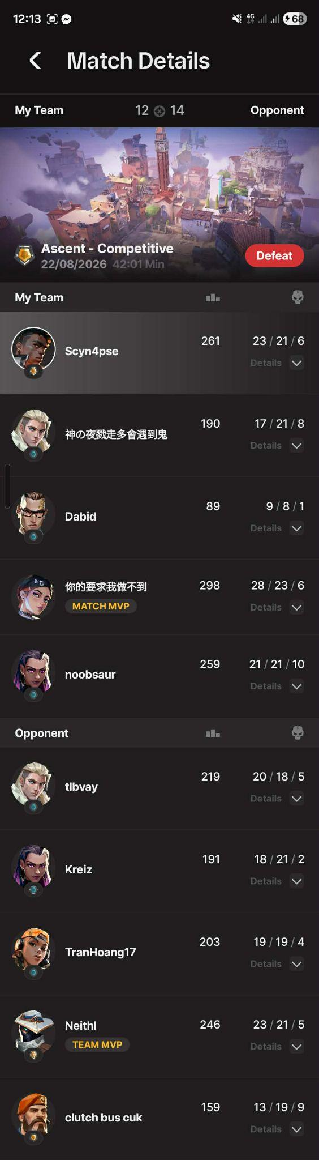
Grading Criteria:

Criteria | Description | Points | Score
UI Replication Accuracy | Accurately reproduces the provided game UI, including overall structure, positioning, proportions, and major elements. | 30
Widget & Layout Structure | Correctly uses Text, Column, Row, Card, and appropriate layout widgets to construct the UI. | 20
Data Variables | All displayed data is declared as variables and uses appropriate data types. | 20
Dynamic Data Display | Variables are properly connected to the UI so changing the data changes the displayed content. | 10
Fallback / Missing Data | Missing or unavailable data has appropriate fallback values or visuals instead of leaving a broken/empty UI. | 10
Assets & Images | Correctly uses project assets and displays the required images, preferably through image variables. | 5
Styling & Visual Details | Applies appropriate colors, typography, spacing, borders, cards, and other visual details from the reference. | 5
Total |  | 100

Hints:
Icons: skull, bar_chart, gps_fixed_outlined
Insert your application screenshot here:


